**DISCUSSION of:**

# Title of the Paper

**Full Reference:** Author 1 Name & Surname, Author 2 Name & Surname, Author 3 Name & Surname (year of publication). Title of the paper. International Journal of Geoengineering Case Histories, http://casehistories.geoengineer.org, Vol.xx, Issue xx, p.xx-xx. doi: to be added by Journal formatting staff.

**Author 1 Name & Surname**, Profession, Company/Organization/Institution, Location (City, Country); email: <main@geocasehistoriesjournal.org>

**Author 2 Name & Surname**, Profession, Company/Organization/Institution, Location (City, Country); email: <main@geocasehistoriesjournal.org>

**Author 3 Name & Surname**, Profession, Company/Organization/Institution, Location (City, Country); email: <main@geocasehistoriesjournal.org>

## KEYWORDS: keyword 1, keyword 2, keyword 3, etc (please use up to nine keywords)

## INTRODUCTION

Paragraph 1 (Bookmarks: Do not assign bookmarks to figures, tables or items within the document, ex. Figure 1.)

Paragraph 2

Paragraph 3

Etc.

## HEADING 1

Paragraph 1

Paragraph 2

Paragraph 3

Paragraph 4

Etc.

## Subheading No.1

Paragraph 1

Paragraph 2

Paragraph 3

Etc.

# Info to be filled by Journal formatting staff. Do not move this box from the first page and do not change its size

## Subheading No.2

Paragraph 1

Paragraph 2

Etc.

## Subheading No.3

Paragraph 1

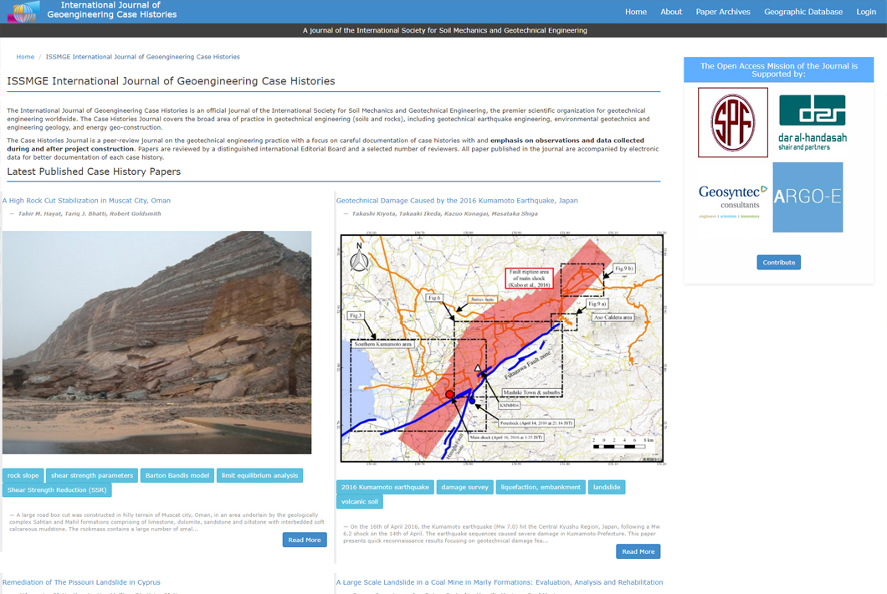

*Figure 1. Description (ISSMGE International Journal of Geoengineering Case Histories).*

*\* should be low case unless it is a name*



*Figure 2. Description (ISSMGE International Journal of Geoengineering Case Histories).*

Paragraph 2

Paragraph 3

## Paragraph 4

## Etc.

## HEADING 2

## Subheading No.1

Paragraph 1

*Table 1. Description (ISSMGE International Journal of Geoengineering Case Histories).*

|  |  |  |  |  |  |
| --- | --- | --- | --- | --- | --- |
| Title 1 | Title 2* | Title 3 | Title 4** | Title 5 | Title 6*** |
| xxx | xxx | xxx | xxx | xxx | xxx |
| xxx | xxx | xxx | xxx | xxx | xxx |
| xxx | xxx | xxx | xxx | xxx | xxx |

## 

* Title 2 - Footnote 1.

** Title 4 - Footnote 2.

*** Title 6– Footnore 3.

Paragraph 2

* Bullet 1. Description.
* Bullet 2. Description.

## Subheading No.2

Subheading No. 2.1

Paragraph 1

1. Numbered 1;
2. Numbered 2;
3. Numbered 3;
4. etc.

## 

Subheading No. 2.2.

Paragraph 1

Paragraph 2

 (1)

 (2)

## CONCLUSION

Paragraph 1

Paragraph 2

Paragraph 3

## ACKNOWLEDGMENTS

Paragraph 1

## 

## REFERENCES

Stahl, D. C., Wolfe, R. W., and Begel, M. (2004). “Improved analysis of timber rivet connections.” J. Struct. Eng., 130(8), 1272-1279.

Garrett, D. L. (2003). “Coupled analysis of floating production systems.” Proc., Int. Symp. on Deep Mooring Systems, ASCE, Reston, Va., 152-167.

Zadeh, L. A. (1981). “Possibility theory and soft data analysis.” Mathematical frontiers of the social and policy sciences, L. Cobb and R. M. Thrall, eds., Westview, Boulder, Colo., 69-129.

## NOTATIONS

xx - explanation Not required by the journal

xx - explanation